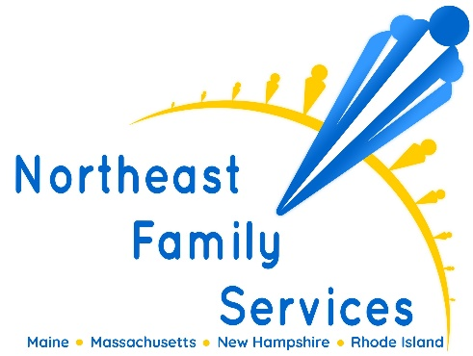
The Board-Certified Behavior Analyst (BCBA) position involves providing and supervising Applied Behavior Analysis (ABA) therapy in both clinical and home-based settings. The BCBA will formulate and implement treatment plans, conduct regular parent trainings and collaborate with team members to ensure effective implementation of the behavior plan.
Responsibilities
- Responsible for the completion of behavioral assessments, short and long-term consultations and direct treatment planning
- Confer with members of the direct support staff and other health team members to exchange, discuss, and evaluate client information for planning, modifying, and coordinating treatment plans
- Work with clients, families, caregivers, direct support staff, and the community to implement the client's treatment plan
- Provide parent training, resources and guidance in behavioral interventions and the basics of ABA in order to support the client’s behavior plan.
- Supervise and evaluate the performance of the direct care staff to ensure proper implementation of treatment plan; provide training and guidance as needed
- Function as an active member of the treatment team at meetings and supervisions
- Review direct support staff documentation and data collection; provide feedback as needed
- Complete necessary documenting (i.e. supervision summaries, program updates, overlaps, etc.)
- Collect data for each goal/objective in a treatment plan to determine effectiveness of interventions
- Initiate contact with new referrals and/or referral sources in a timely manner.
Required Experience
- Experience in applied settings developing and implementing behavioral interventions and teaching programs
- Master's Degree or PhD in Applied Behavior Analysis, Special Education, Psychology, or related field
- BCBA (BCBA-D credential preferred); BCaBA acceptable under additional supervision or BCBA licensed as LBA
- Valid driver’s license with reliable and consistent access to a vehicle
Benefits
- Flexible Schedule
- Health & Dental
- Paid vacation & sick time
- 9 paid holidays
- 401k retirement plan
- Tuition Assistance
- Company provided laptop and cell phone

